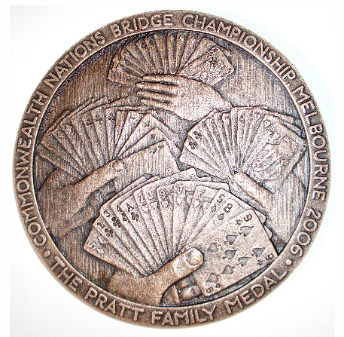
CNBC – SOUVENIR REQUEST

Name: ………………………………..……………………………

Address: ………………………………….…………………….……
(for postage)
………………………………….…………………….……

E-Mail Address: ………………………………………………………

I wish to purchase the following items:
Cheques made out to CNBC

Souvenir Shoulder Bag @ $65 each ………………

Pratt Medallion @ $50 each ………………

Souvenir Booklet @ $10 each ………………

Souvenir Parker Pen @ 15 each ………………

Souvenir Drink Bottle @ $25 each ………………

CD of Event (not available until mid-May 06) @ $25 ………………

Total Value of Your Order $...................

Items only available while stocks last

Address: A.L.Halmos; 14 Galtum Ave, Bentleigh

Addre

